


🌿 Eco Committee Update – March 2026

Date – 27th March 2026
Attendance – Miss Smith & Eco Committee

Our Eco Committee has been hard at work improving our school environment and
making our outdoor spaces more nature-friendly.
💨 Storm Damage in the Outdoor Learning Area
Earlier this week, strong winds caused significant damage to our Outdoor Learning Area.
The teepee structure was unfortunately blown down and will need repairs.

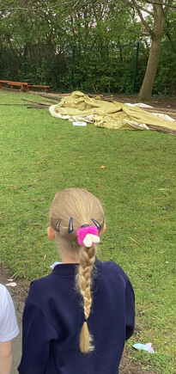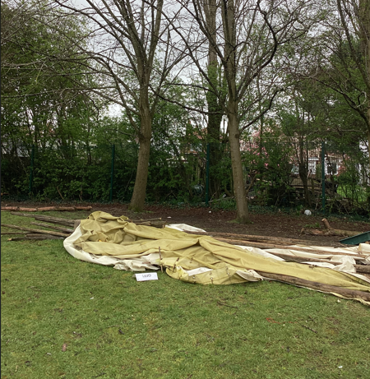

Despite this setback, the Eco Committee stayed positive and immediately
began thinking creatively about how the space could be improved.

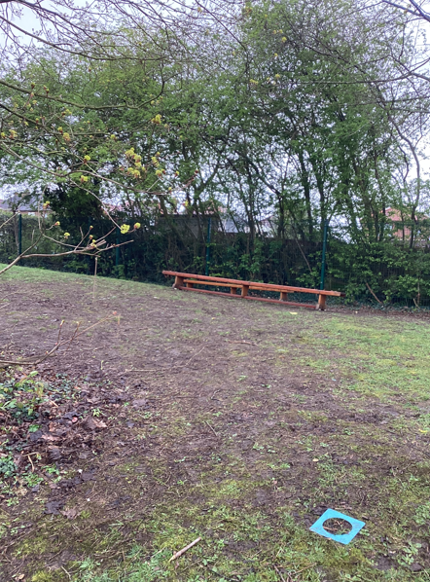

The Eco-Committee met, and using widget symbols for inclusivity, worked on new ideas
for the area to be used a an area for learning as well as improving the ecology of the
school site so we are Bug Friendly
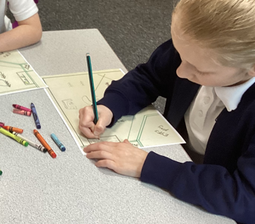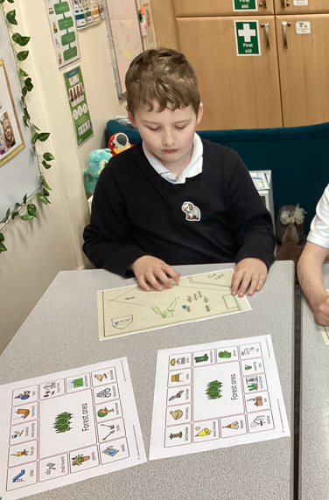

🌱 Planning a Bug-Friendly Learning Space
During their meeting on 27th March 2026, Miss Smith and the Eco Committee gathered
—using widget symbols to ensure the discussion was accessible and inclusive to all pupils.

The children explored new ideas to transform the Outdoor Area into a space that
supports learning and local ecology. Their goal is to create an inviting environment
that is Bug Friendly, encouraging wildlife while giving pupils a place to learn
and explore nature.

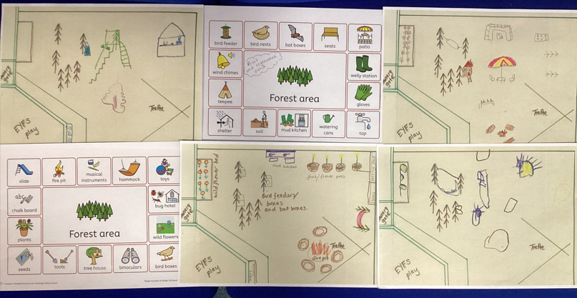

Ideas included:
- Adding bug habitats and mini-beast areas
- Planting flowers that attract pollinators
- Creating calm, sheltered learning zones
- Making use of natural materials for outdoor activities
Our young environmental leaders showed great teamwork, resilience, and imagination!

📸 A Look at the Day
The meeting included photographs of the damage and the committee's
planning session, helping pupils understand the real impact of weather on
outdoor structures and the importance of caring for our shared spaces.

