

KINDNESS CAPTAINS MINUTES

Friday 30th January 2026 Miss Bailey
Welcome and Purpose of Meeting
Miss Bailey opened the meeting and outlined that the session would focus on reviewing kindness within the school community. The purpose was to assess how well students demonstrate different aspects of kindness and to identify areas of strength and areas for improvement.
Kindness Audit Overview
The Kindness Captains conducted a whole-school Kindness Audit.
- Students used a grid of kindness words to guide their observations.
- They identified real examples of kind actions occurring around the school.
Rating System Used
To evaluate the level of kindness shown, the following colour-coded system was applied:
- Green — Students are performing the kindness action well.
- Pink — This kindness action needs further development.
The colour ratings helped highlight common strengths as well as behaviours the school would like to support more intentionally.

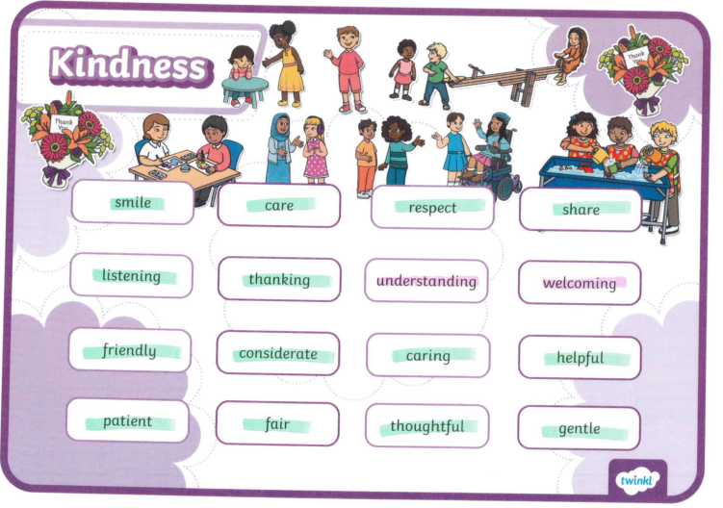

Celebration of Kindness
Certificates were awarded to students who demonstrated exceptional kindness throughout the audit period.
This recognition aimed to encourage positive behaviour and spotlight role models across the school.

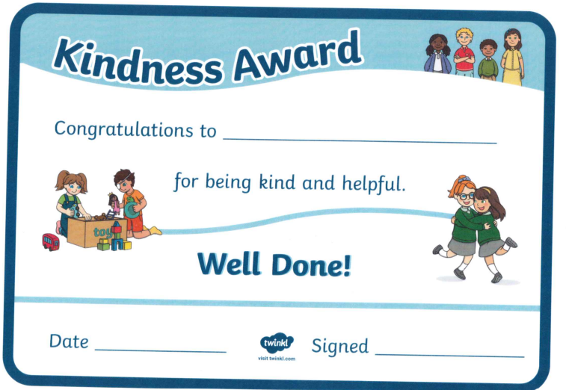

Next Steps / Actions
- Continue regular Kindness Audits each term to monitor progress.
- Use findings to inform class discussions and assemblies on kindness.
- Support students in actions identified as “Pink” with targeted encouragement and activities.
- Review the list of kindness words to expand or adjust based on future needs.

Meeting Close
Miss Bailey thanked the Kindness Captains for their thoughtful work and acknowledged the positive impact of their leadership across the school.

